Git & IntelliJ Assignment - Ette Divya Nikitha
- What is the use of the git add command?
Git add stages changes both new files or modified files so they are ready to be committed

- Write the command to create a branch “feature-group”.
git branch feature-group

- What is a pull request? Write the steps involved in creating a pull request.
A pull request is a way for developers to review and discuss changes made to code before merging it into the main branch
Steps involved in creating a pull request:-
- Open GitHub
- Click on Compare & pull request
- Add description
- Click on Create pull request

- How do you add collaborators?
- Go to the GitHub repository
- Click on Settings
- Select Collaborators
- Enter the username/email
- Click Add

- What is the command used to commit our changes in github repo?
Git commit –m “commit message”

- Create a github account and repository to save all your assignment tasks. Example repository name: rg-assignments
https://github.com/divyaette/rg-assignments

- Create a branch called feature-java(you can use it later to push all your java related tasks to this branch)
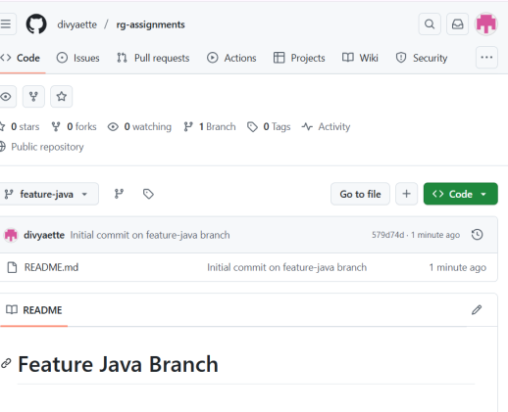
- Install IntelliJ IDE. Create a simple java project displaying “Hello World!!”and share the screenshot.
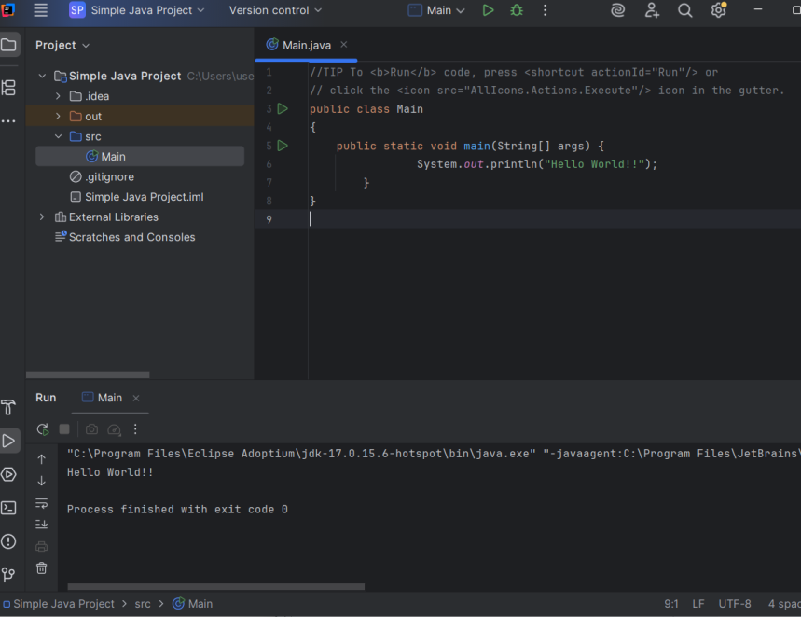

- In IntelliJ IDE, explore the shortcut keys for the following
  - To run the project - Shift + F10
  - To select a line - Home → Shift + End
  - To comment/uncomment a line - Ctrl + /
  - To delete a line - Ctrl + Y

